

Universidad Católica de la Santísima Concepción

Facultad de Ciencias

Alonso de Ribera 2850,

Chile, CP 4090541

(+56) 41-2347027 Santiago, Chile, 24 March 2023

*Dear Editor,*

I am writing to you on behalf of my co-authors in response to the editorial comments on our manuscript entitled, "Hydroclimate variations over the last 17,000 years as estimated by leaf waxes in rodent middens from the south-central Atacama Desert, Chile". We would like to express our gratitude to the reviewers and the Professor Patrick Rioual for their careful evaluation of our manuscript. Their feedback has greatly improved the quality of our work. In this document, we have provided a comprehensive explanation of the changes we have made to the manuscript in accordance with the editor's recommendations. We are confident that these revisions have strengthened our study and we look forward to its possible publication in Quaternary Science Reviews.

*Sincerely,*

*Matías Frugone-Álvarez*

## 1. Response to editor comments

### 1.1. Page 1:

Do not use a comma to separate thousands in number with 4 digits, only do it with numbers with 4 digits or more: e.g. … 4500-4000 m asl …. 17,000 years … This should be corrected throughout the text.

***Reply specific comments 1.1.*: We appreciate the editor's comment*. D****one*

**1.2. Page 2:**

On the second row: be consistent with the spelling of “paleo” (US) vs “palaeo” (UK). It seems that you have mostly used British spelling in the text, so replace “paleomidden” by “palaeomidden” throughout the manuscript (text and figure legends).

***Reply specific comments 1.2.*: We appreciate the editor's comment, we have changed "paleomidden" by "palaeomidden"*. Done***

The idea of keywords is not to repeat words already included in the title. With that in mind I would keep “Leaf cuticular waxes” but replace “Rodent Middens, Atacama Desert, Hydroclimate” by other important terms used in the abstract such as, for example: elevation gradient; Central Andes Pluvial Event; n-alkane; chemo-taxonomy; ACL; CPI. I would also replace “Quaternary” which is too broad, by “Pleistocene; Holocene”

***Reply specific comments 1.2.*: We appreciate the editor's comment, we have changed keywords to:**

- Leaf cuticular waxes

- Central Andes Pluvial Event

- Chemo-taxonomy

- Palaeoclimate

- Pleistocene-Holocene transition

**1.3. Page 3:**

Page 3: 2nd paragraph, 2nd line: delete the hyphen in “humidity”

6th line: delete the hyphen in “aldehydes”

17th line: … of the plants studied… (add “the”)

***Reply specific comments 1.3.*: *Done***

**1.4. Page 4:**

Page 4: 2nd paragraph, 3rd line: delete the hyphen in “palaeomiddens”

7th line: …for these reasons: … (add an “s”)

***Reply specific comments 1.4.*: *Done***

**1.5. Page 6:**

Page 6: in the legend for Fig.1 Change to “palaeomiddens”

***Reply specific comments 1.5.*: *Done***

**1.6. Page 7:**

Page 7: Palaeoecology and Palaeoenvironments

In the 2nd paragraph, 4th and 5th lines remove the spaces between the number and the degree symbols

On the 10th and 12th lines, use British spelling for “derivatised”, “ionisation”

14th line, remove the spaces between the number and the degree symbol

***Reply specific comments 1.6.*: *Done***

**1.7. Page 8:**

Page 8, paragraph 2.4, on the 6th line, correct spelling of “bootstrapping” (a “t” is missing)

On the 8th line, remove the capital R for “rodent”

***Reply specific comments 1.7.*: *Done***

**1.8. Page 9:**

Page 9, 7th and 10th lines, use superscript for R2

***Reply specific comments 1.8.*: *Done***

**1.9. Page 11:**

Page 11, in the 1st line, delete “either”

On the 8th line, Baccharis tola (remove the capital T for the species name, only the genus name should have a capital)

***Reply specific comments 1.9.*: *Done***

**1.10. Page 12:**

Page 12: legend of Fig.3: correct spelling of “palaeomiddens”

In Fig.3, for the label of the y-axis, change to “Relative abundance index (0-5)”

***Reply specific comments 1.10.*: *Done***

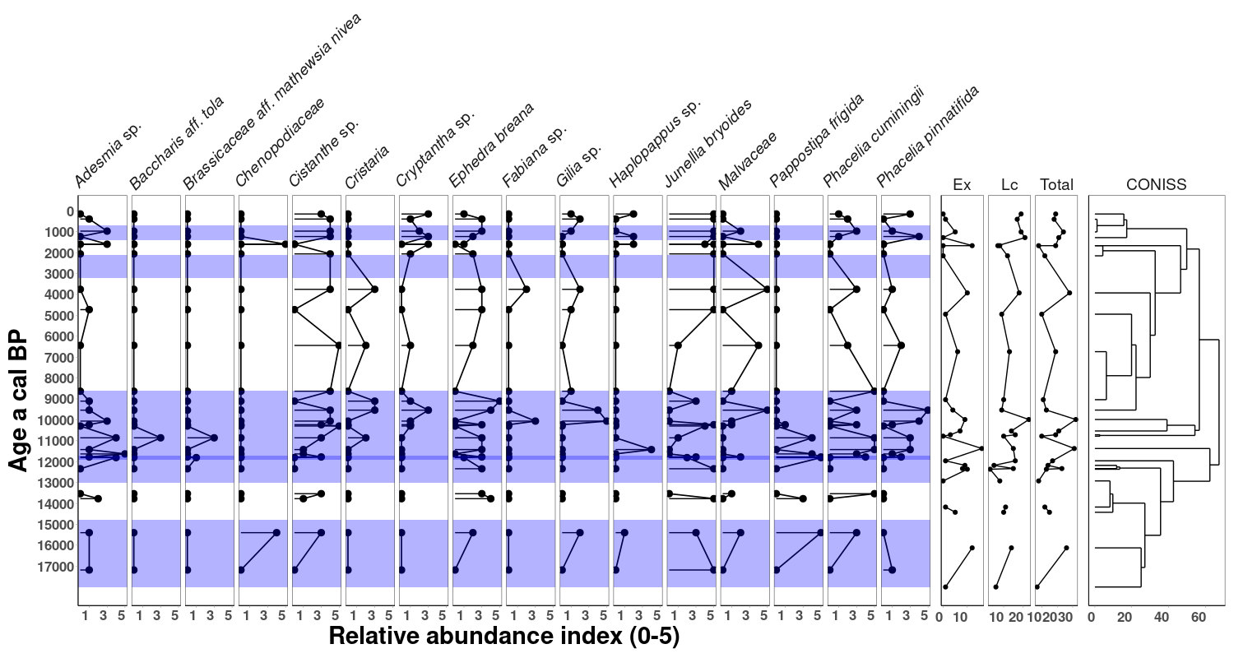

**1.11. Page 13:**

Page 13: on the 2nd line, add “ and” such as: Two grass samples, dated between 970 (QIN237B) and 11,780 (QIN 214b) a cal BP…

In the legend for fig.4: … obtained from the delete palaeomiddens… (also delete the hyphen in “palaeomiddens”)

***Reply specific comments 1.11.*: *Done***

**1.12. Page 14:**

Page 14:

2nd line: Contreras et al. (2022) provided a… (use the past tense for consistency with the rest of the paragraph in which you described results from previous research)

3rd line: …a CAM species… (a s is missing at the end of species)

4th line:… that ranged from…

6th line: … showed a higher…

13th line: …observed…

2nd paragraph, 12th line: remove the hyphen in “dominance”

***Reply specific comments 1.12.*: *Done***

**1.13. Page 15:**

Page 15

In the title for the 1st paragraph: … in a 17,000 years long rodent midden record….

In the 1st and 3rd lines, I would use the present tense to discuss the results of your analyses: The analysis …shows… / …These wax distributions are similar to…

6th line: When we compare the…

8th line: … we note…

14th line: … we cannot rule out… …preferences… (remove the hyphen)

15th line: …analysis shows… (a space is missing between these 2 words)

17th line: … which discriminates… (the subject of this verb is singular: “our RDA analysis”)

20th line: palaeomiddens

2nd paragraph, 1st line: Palaeomidden records…

***Reply specific comments 1.13.*: *Done***

**1.14. Page 16:**

Page 16

3rd line: …proposed to explain…

2nd paragraph, 1st line: ….from palaeomidden records… (correct spelling, remove the first “s”)

7th line: palaeomiddens

13th line: use the plural: … in these modern middens…

14th line: distributions (remove the hyphen) …./…. palaeomiddens

17th line: palaeomiddens

22nd line: palaeomidden series

23rd line: correct spelling of “flood” (not “food”)

***Reply specific comments 1.14.*: *Done***

**1.15. Page 17:**

Page 17

1st line: palaeomidden records…

4th line: ….reconstructed… (use the past tense when describing results from previous studies)

14th line: at ca. 10,780 ka cal BP… (please check the age you gave, but surely 17.780 ka is not correct)

16th and 19th lines: be consistent in the way you report the ages, change such as: (ca. 14.8 and 13.1 ka cal BP)

27th line: a space is missing after “south”

***Reply specific comments 1.15.*: *Done***

**1.16. Page 18:**

Page 18

In the legend for Fig. 5:

1st line:… from palaeomidden records…

2nd line: …palaeoclimate records. … from palaeomiddens…

***Reply specific comments 1.16.*: *Done***

**1.17. Page 19:**

Page 19:

1st line: use the plural for “analyses”

1st line: … from palaeomiddens…

3rd line: palaeomidden record…

9th line: …o0f the SASM system…

In the conclusion:

1st line: …from palaeomiddens…

7th line: …n-alkanoic acids are the… (be consistent and use the present tense, as you did in the beginning of that sentence).

8th line: … are n-C27 and… …/… that are dominated by…

12th line: palaeomiddens are…

14th line: … the palaeomidden record…

15th line: …palaeomiddens show…

***Reply specific comments 1.17.*: *Done***

**1.18. Page 20:**

Page 20

7th line: …other palaeoclimate proxies…

8th line: …and genetic information across… (delete to)

9th line: …other palaeoclimate records…

In the acknowledgements:

…the indigenous community of… …. for help with sample analysis and logistical support …

This research was supported by…

***Reply specific comments 1.18.*: *Done***

**1.19. Page 23:**

In the references:

Page 23:

Braun-Blanquet et al. Give the full list of authors, If this reference is a book, give the name of the publisher, the city, the number of pages. Delete the weblink as it does not correspond to this reference.

Inglis et al. : start a new line

***Reply specific comments 1.19.*: *Done.***

Braun-Blanquet, J. 1932. Plant sociology: the Study of Plant Communities. Transl. by G. D. Fuller and H. S. Conard. New York; NY: McGraw-Hill Book Co. pp 1–439

**1.20. Page 25:**

Page 25:

Spaulding 1990: there is no journal title, no page numbers. Please check it

***Reply specific comments 1.20.*: *Done.***

Spaulding, W.G., 1990. Vegetational and climatic development of the mojave desert: The last glacial maximum. Packratmiddens: the last 40,000 years of biotic change. In Packrat Middens: The Last 40,000 Years of Biotic Change; Betancourt, J.L., Van Devender, T.R., Martin, P.S., Eds. University of Arizona Press: Tucson, AZ, USA. 166–99.